**ASSIGNMENT 2 REPEATED WITH FLOATING POINT OPERATIONS**

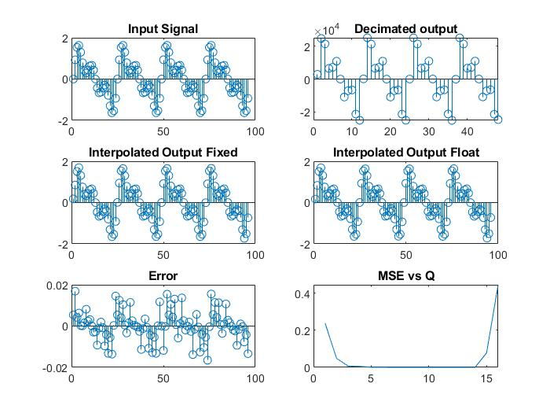

Figure 1 OUTPUT WITH M=L=2

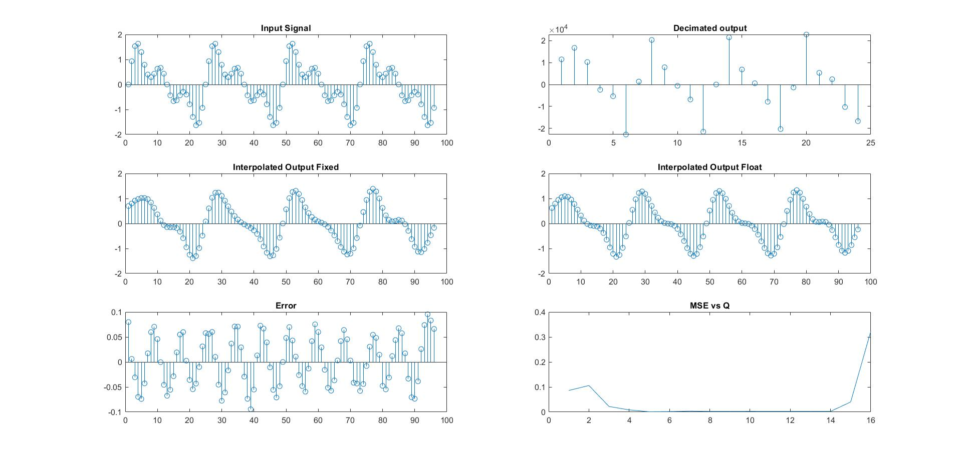

Figure 2 OUTPUT WITH M=L=4

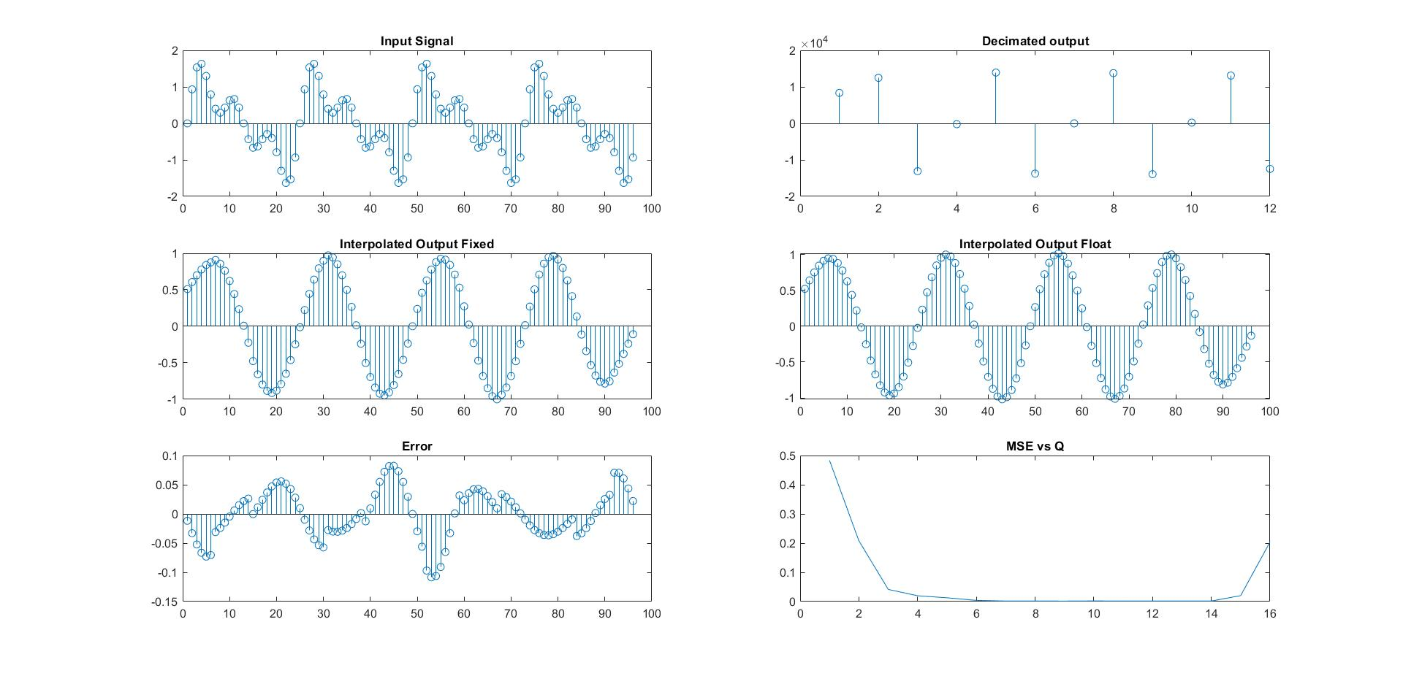

Figure 3 OUTPUT WITH M=L=8

**ASSIGNMENT 3 WITH FIXED POINT CALCULATIONS**

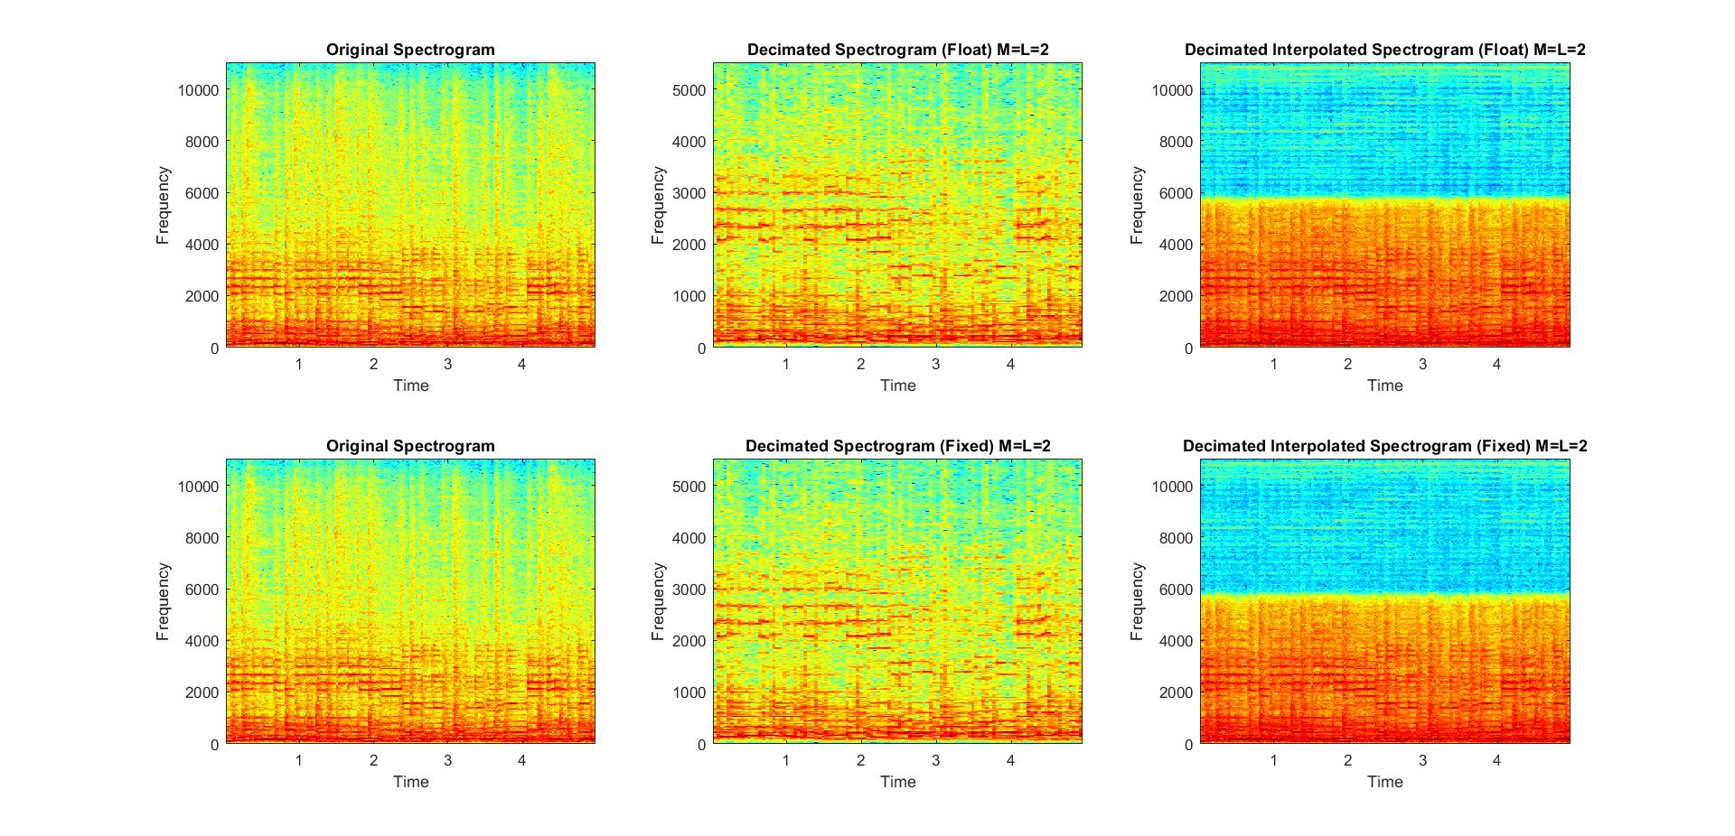

Figure OUTPUT SPECTOGRAM FOR M=L=2

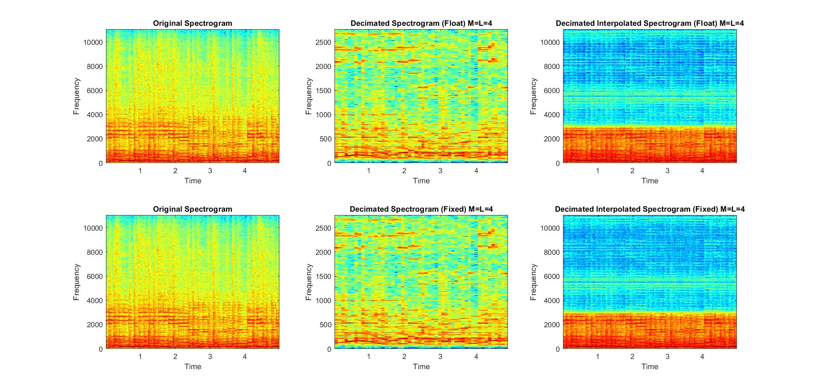

Figure OUTPUT SPECTOGRAM FOR M=L=4

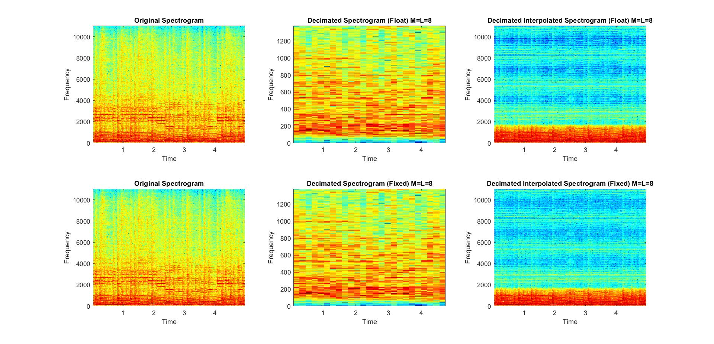

Figure OUTPUT SPECTOGRAM FOR M=L=8